**Create a React Application named “cricketapp” with the following components:  
  
SOLUTION:**

**App.js: (when flag=True)**

import React from 'react';

import ListofPlayers from './components/ListofPlayers';

import IndianPlayers from './components/IndianPlayers';

function App() {

const flag = true;

return (

<div className="App">

<h1>🏏 Cricket App</h1>

{flag ? <ListofPlayers /> : <IndianPlayers />}

</div>

);

}

export default App;  
  
**ListofPlayers.js:**

// src/components/ListofPlayers.js

import React from 'react';

const ListofPlayers = () => {

const players = [

{ name: "Virat Kohli", score: 95 },

{ name: "Rohit Sharma", score: 80 },

{ name: "KL Rahul", score: 45 },

{ name: "Shikhar Dhawan", score: 30 },

{ name: "Hardik Pandya", score: 77 },

{ name: "Ravindra Jadeja", score: 65 },

{ name: "Rishabh Pant", score: 85 },

{ name: "Shreyas Iyer", score: 55 },

{ name: "Bumrah", score: 90 },

{ name: "Ashwin", score: 72 },

{ name: "Chahal", score: 66 },

];

const filteredPlayers = players.filter(player => player.score < 70);

return (

<div>

<h2>All Players:</h2>

<ul>

{players.map((player, index) => (

<li key={index}>{player.name} - {player.score}</li>

))}

</ul>

<h3>Players with Score Below 70:</h3>

<ul>

{filteredPlayers.map((player, index) => (

<li key={index}>{player.name} - {player.score}</li>

))}

</ul>

</div>

);

};

export default ListofPlayers;  
  
**IndianPlayers.js:**

import React from 'react';

const IndianPlayers = () => {

const players = ["Dhoni", "Kohli", "Raina", "Bhuvi", "Rahane", "Gill"];

const [p1, p2, p3, p4, p5, p6] = players;

const oddPlayers = [p1, p3, p5];

const evenPlayers = [p2, p4, p6];

const T20players = ["Surya", "Samson", "Arshdeep"];

const RanjiTrophyPlayers = ["Pujara", "Karun Nair", "Saha"];

const allPlayers = [...T20players, ...RanjiTrophyPlayers];

return (

<div>

<h2>Indian Players - Odd and Even Teams</h2>

<p><strong>Odd Team Players:</strong> {oddPlayers.join(', ')}</p>

<p><strong>Even Team Players:</strong> {evenPlayers.join(', ')}</p>

<h3>Merged T20 and Ranji Trophy Players:</h3>

<p>{allPlayers.join(', ')}</p>

</div>

);

};

export default IndianPlayers;

**OUTPUT:**

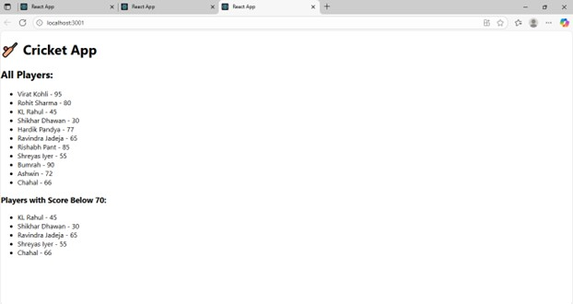

**Solution**

App.js(when flag=False):

import React from 'react';

function App() {

const flag = false;

const players = [

"Sachin1", // index 0 - odd

"Dhoni2", // index 1 - even

"Virat3", // index 2 - odd

"Rohit4", // index 3 - even

"Yuvraj5", // index 4 - odd

"Raina6" // index 5 - even

];

const indianPlayers = [

"Mr. First Player",

"Mr. Second Player",

"Mr. Third Player",

"Mr. Fourth Player",

"Mr. Fifth Player",

"Mr. Sixth Player"

];

const oddPlayers = players.filter((_, index) => index % 2 === 0);

const evenPlayers = players.filter((_, index) => index % 2 !== 0);

return (

<div style={{ padding: '20px', fontFamily: 'Arial' }}>

<h1>Cricketer App</h1>

{!flag && (

<>

<h2>Odd Players</h2>

<ul>

{oddPlayers.map((player, index) => (

<li key={index}>Player {index * 2 + 1}: {player}</li>

))}

</ul>

<h2>Even Players</h2>

<ul>

{evenPlayers.map((player, index) => (

<li key={index}>Player {index * 2 + 2}: {player}</li>

))}

</ul>

<h2>List of Indian Players Merged:</h2>

<ul>

{indianPlayers.map((name, index) => (

<li key={index}>{name}</li>

))}

</ul>

</>

)}

</div>

);

}

export default App;

**OUTPUT:**

